Water Conservation and the Public Water Utility

Author: Alfre Wimberley Editors: Lauren Brown, Lisa Nguyen, and Andy Honeycutt

Current estimates of freshwater consumption predict a global water stress crisis in roughly 167 countries by 2040⁷. Water is a vital resource that should be conserved and well-managed. Managing and conserving water while serving all customers connected to the public water utility is of the utmost importance. This goal is often hard to achieve as a public water utility while meeting financial requirements to support infrastructure maintenance, service, and expansion. Therein lies the conflict of most water utilities; conserving water successfully while raising enough revenue to support infrastructure maintenance and possible expansion. These concerns around water conservation particularly hit hard with water utilities in areas of water stress.

Getting in the Know
When conservation is part of a water utility’s operational objective, education is the beginning of any successful program to effectively reduce water consumption. Not only is it important to educate within the utility, but there is vital educational information that needs to be provided to utility customers to encourage “green” behavior. These educational points can include information on limiting water consumption by checking for in-home leaks, planting native plants to reduce the need for irrigation, and installing low-flow water fixtures, shorter showers, just to name a few.

Within the utility, sharing with the staff organizational goals and concentrating efforts for resource conservation brings the most success internally. For example, encouraging staff to increase customer engagement through access to metering customer portals, which provides almost real-time usage information on water consumption. For the conservation goals to be effectively shared, all departments have to be engaged and understand where they can contribute value to meeting the utility’s water reduction initiatives. For example, the City of Bloomington, Indiana developed an effective water conservation plan in 2014¹ that has multiple prongs to address the public such as placing educational material in billing information, annual conservation reports, and keeping the utility’s website updated. Finding out which communication paths work best for each utility’s customer base is one of the vital steps to better water management.

New water infrastructure, specifically with customer metering, can contribute significantly to water resource management but it has to be implemented correctly. The focus on infrastructure should be driven towards sustainable operations, effective programs for customer engagement, and a continued focus on system data and trends in order to support tangible results by the utility. These efforts may include enforcement of water restrictions, application of distribution leak detection, enforcement of customers-side leak repair, and district metering to identify areas of potential water loss. Nonetheless, having constantly expanding environmentally-friendly infrastructure to compensate for customer overconsumption should not replace the need for customer education about the importance of water resource management. The most effective programs for conservation balances advanced metering technologies with effective customer education.

Advanced Metering and Conservation
As a water utility interested in high quality service for its customers, there must be a point of discussion between the utility, customers, and the municipality for cooperative “green” programs supported by all stakeholders. To address this challenge, it is recommended by Ceres, a sustainability nonprofit organization, and the University of North Carolina Environmental Finance Center, an environmental financial analysis nonprofit, to improve and increase communication with customers more than when payments are due². This could take the form of alerts on varying technological platforms or simply increased customer interaction with the utility. With an advanced metering system, often referred to as Advanced Metering Infrastructure (AMI), the Meter Data Management System (MDMS) would be able to flag any operational or usage anomalies in the system by communicating with the utility as well as alert customers of water usage through custom portals. These alerts are based on algorithms built into the MDMS that help to quickly identify changing patterns within the water system and inform operators and customers based on the type of alert. Having the alerts allows for more information on consumption to be reported and for a resolution to be quickly found for the system. Additionally, information can be left with customers in a physical form (i.e. bill inserts and newsletters), social media, or public meetings to share information about the goals of the water utility with customers’ interests in mind.

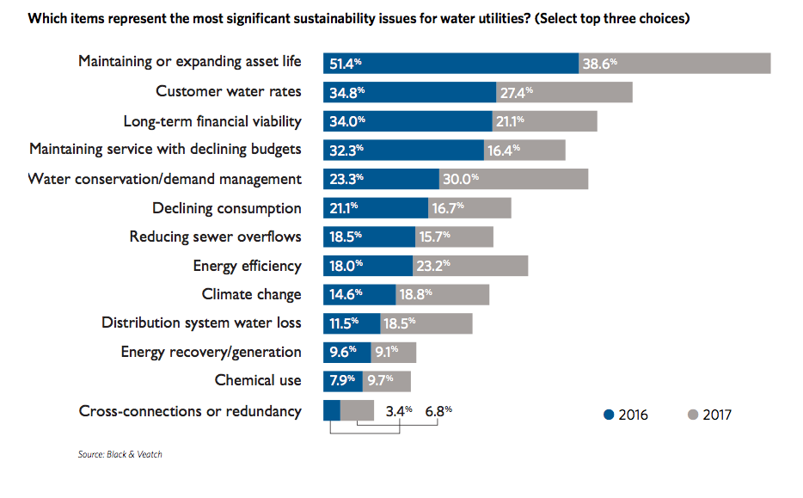
Most notably, social media is an effective but underutilized tool for utilities to quickly and effectively communicate with their customer bases. Only 65% of major cities, 45% of mid-size, and less than 33% of small-sized utilities are active on social media³. This is important to note considering that social media platforms like Facebook have broken barriers of age and income and are valuable to any communication arsenal, especially with the utility’s varied customer base.

If there is a social media presence with the water utility, often the communications are focused on public relations or promotional information such as awards, new hires, or events that, while important, are challenged inholding customer attention³ or driving consistent visits to the social media platform There is a vested interest by both the public utility and its customers in receiving practical information from the utility such as drought limitations, ways to save on their monthly bills, or service updates. This has been successfully implemented in times of normalcy and emergency. For example, in South Carolina³, social media was used to update customers on service interruptions and other advisories during hurricanes. The municipalities that joined in this effort included the Town of Mt. Pleasant, Town of Edisto Beach, City of North Charleston, and City of Isle of Palms.
Figure 1: Displays the top concerns of water utilities² with implementing sustainability goals.

The Cost/Benefit of Conservation
Increased communication not only allows for the water utility to share with customers why water conservation does matter, but how customers contribute to water conservation, highlight the utility’s interest in conserving water, and what the utility is doing to contribute as well. The fact that the utility participating in “green” infrastructure does come with a price tag is important to consider and the balance between utility investments of resources, both in money and by staff, and the derived benefits of conservation and resource management on costs of water production and the environmental contributions related to water shortages .
As noted in Figure 1, the top three concerns of water utilities in 2016 and 2017 are maintaining or expanding asset life, customer water rates, and long-term financial viability². Along with increased communication, the message to customers should be highlighting the importance of maintenance to the infrastructure of the water utility and the price tag associated that will be passed on to customers in the form of higher rates. The Environmental Protection Agency (EPA) underscores the importance of that perspective being imperative to impress on customers due to conventional thinking in the customer base⁵³. This conventional thinking typically is if consumption is lowered so should the water bill. This conclusion, incorrectly, does not account for the fixed and variable cost of running a public water utility beyond simply pro-rating consumption from the customers. Reassuring customers that being more water efficient long-term is a priority. Long-term efficiency allows for the minimization of the need for expansion of the water utility infrastructure and eventual maintenance of a larger system.

The value of a water utility not focused on constantly expanding is a water utility turning its attention to, “leak detection, replacing aging infrastructure, and improving efficiencies...”⁴. This results in the lower bills over time. If this is not effectively communicated to customers, the risk to the water utility is an inability to afford increasing customer need with a stagnating revenue source to manage the demand.

Usually, the water utility is faced with resistance when requesting raised rates. This persistent problem can, also, be limited with increased communication, which can be vital to funding conservation plans. In Figure 2, education and active outreach are the dominant chosen methods water utilities are currently using to increase funds for infrastructure while consumption rates are reduced do to successful water resource management..

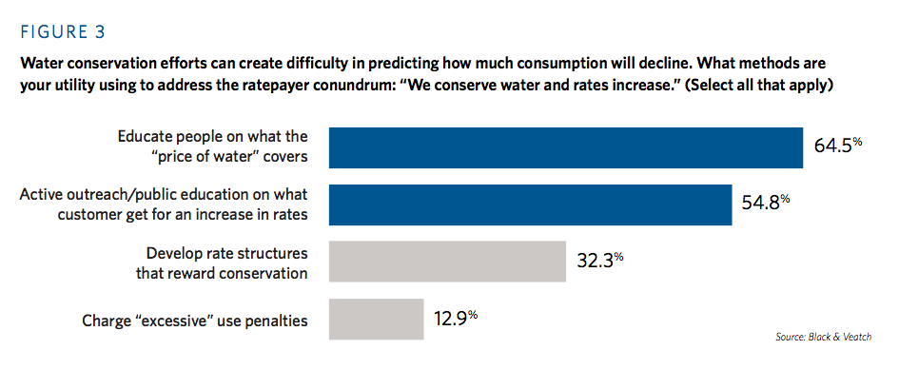
Figure 2: Displays the top methods utilizes by water utilities to educate customers and increase the conservation of water².

Additional Benefits of Resource Conservation

There are additional areas that utilities can reach conservation goals effectively while avoiding common pitfalls. These areas include the environmental impact that the utility could make with new infrastructure, opportunities to reduce the energy footprint of the utility, and changing perspectives on how the utility manages to a more proactive than reactive operational culture.

Environmental

When public water utility infrastructure is expanded it often takes the form of reservoirs, dams, and sometimes pumping from surface waters. These anthropogenic adjustments, according to the United States Geological Survey (USGS), can represent significant ecological impairments associated with converting lotic (moving water) to lentic (non-flowing water) that can compromise riverine species. Some of these changes involve increased water speed that can lead to increased erosion or sedimentation, changed water quality, eliminated reasonable biodiversity, and changed aquatic living conditions³. For example, in North Carolina, the damming of water resources has led to increased evaporation rates. Evaporation rates are of note because increased evaporation rates contribute to greenhouse gas (GHG) emissions and lower the water available for the local utility to access. These historic evaporation rates are recorded and kept by the State Climate Office of North Carolina for many locations across the Southeastern United States.
Did you know that increasing the evaporation of water not only lowers the amount of water that can be used by the municipality, but it is a contributor to an increase in GHGs in the atmosphere? **The U.S. Bureau of Reclamation is also engaged in research to improve estimates of reservoir evaporation [1]. **

Additionally, there is economic value to respecting the natural built environment. According to a Georgia Environmental Protection Division March 2008 paper, dams and reservoirs can cost $4,000 per 1,000 gallons of capacity whereas water efficiency costs between $0.46 to $250 per 1,000 gallons saved of new capacity³.

Energy

An aspect not commonly considered by the consumer or mentioned in water conservation is the simultaneous energy conservation that can occur at the Water-Energy Nexus. It takes energy to pump, treat, and transport water through a municipality’s infrastructure. By limiting water consumption, energy consumption is lowered and can limit the amount of GHGs released in the atmosphere by reducing energy used.

Management

After customer support has been obtained and conservation measures are being implemented, the largest challenge is managing the system and changing the culture surrounding the goals of the water utility. Now that expansion pressure has been lowered, the public will expect those eventual lower water bills. How is this possible? The simple answer is improved data analytics to account for all water inputs into the infrastructure and a deeper understanding of the user-base. Increased water usage data and analytics through AMI is a key foundational component of effectively monitoring and managing water usage, changes in water operations, conservation enforcement, and consumption trending to name a few.

Some AMI functionality options for the utility to consider are acoustic leak detection, pressure monitoring sensors, and a utility management portal. These systems have good synergy for the utility by not only using acoustic technology to identify leaks before they become catastrophic but help prevent line breaks in the distribution infrastructure with alert notifications of abnormal pressure in the water system. Advanced water meters are often equipped to support these monitoring systems to further prevent the loss of water as well as support Non-Revenue Water Loss (NRWL) management by the utility. The utility portal allows for more targeted meter visitation, which will limit truck roll-out and fuel consumption, by providing more detail on the needs of the system through trending reports, alerts, and notifications. For example, the AMI network would be able to notify the utility staff when a meter is no longer reporting due to a broken register or a reporting failure due to tampering. Though almost real-time system-wide view, utility operators and customers may respond swiftly and effectively to changes within the water distribution system that lowers operational costs, helps with customer bills, and preserves a vital and limited natural resource.

Case Study
Asheville, NC6 initiated a program utilizing the methods being suggested like engaging social media and more effective infrastructural management with much success. Using the American Water Works Association (AWWA) standards, this municipality was able to reduce losses of water from 6 million gallons per day (MGD) in 2012 to 5 MGD in 2016. This utility invested resources into leak detection, meter testing, zone metering, pressure reduction, and evaluating unbilled uses. This changed the outlook of the City because they were no longer looking for new water resources to support demand. By keeping demand down, current water resources could serve the City’s utility customers more easily.

Conclusion

Water stress occurs in more areas than in the American Southwest and West. This can be due to permanently changing rainfall patterns or subject to seasonal changes. Thus, Federal organizations like the National Oceanic and Atmospheric Administration (NOAA) and the United States Department of Agriculture (USDA) keep track of drought conditions across the country. As can be noted in Figure 4, as recently as February 2018, large areas of North Carolina, a rather ‘wet’ East Coast state, are considered ‘Abnormally Dry’ or in a ‘Moderate Drought’ area. Now, in August, North Carolina has seen heavy rainfall and there are almost no areas affected with water shortages.
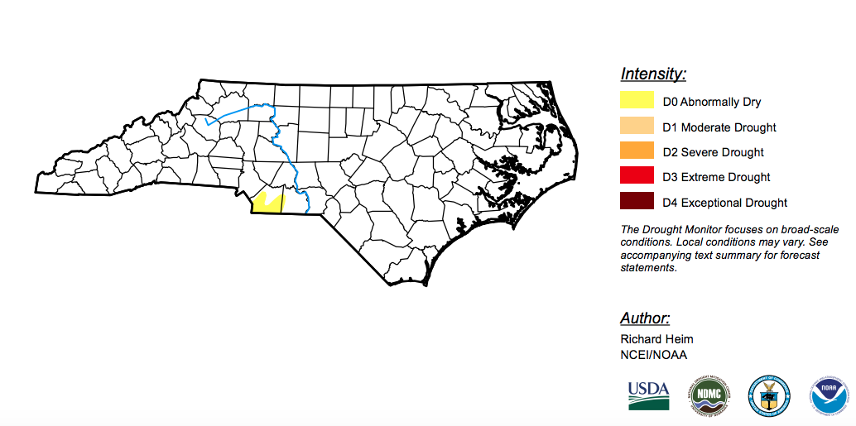

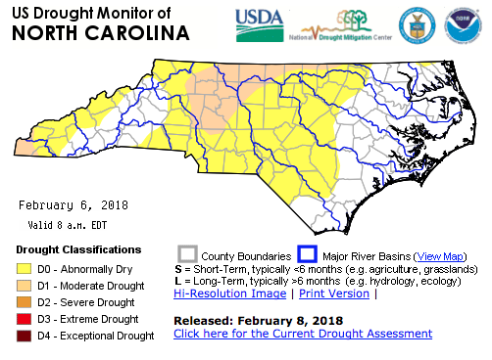

Figure 4: This figure displays areas of water stress in the State of North Carolina [2].

Dealing with the varying conditions in the US can be difficult in relation to precipitation levels and consumption, but utilities do not need to be victims of circumstance. Taking control of their futures for the benefit of the environment, customer base, and financial future include better customer communication, environmental management, and implementing smarter monitoring systems to benefit everyone.

More than anything, the key to balancing the need to keep revenue at levels good enough to maintain water infrastructure while meeting the needs of the customers at a reasonable price is customer communication and changing the culture of the water utility from expansion to one of quality in service for an increasingly environmentally conscious public.

About MeterSYS:
MeterSYS® is a Raleigh, North Carolina based advanced utility metering services company providing feasibility analysis, technology procurement services, and systems implementation program management. The company also specializes in P3 (Public-Private Partnership) meter system management through its design, build, finance, operate, and maintain (DBFOM) Metering as a Service® Program.

About the Author:

Alfre Wimberley graduated from the University of North Carolina at Chapel Hill with a Bachelors of Science in Environmental Science, a minor in Chemistry, and a concentration in Energy and Sustainability. She fulfills a Consulting Analyst position at the firm supporting general client deliverables and the development of our conservation messaging.

Lightbulb Citations:

[1] National Oceanic and Atmospheric Administration, NOAA. “Greenhouse Gases.” National Climatic Data Center, NOAA, 2016, www.ncdc.noaa.gov/monitoring-references/faq/greenhouse-gases.php?section=watervapor.

[2] USDA. “United States Drought Monitor.” United States Drought Monitor, USDA, 6 Feb. 2018, droughtmonitor.unl.edu/CurrentMap/StateDroughtMonitor.aspx?NC.

City of Bloomington Utilities Department. City of Bloomington Utilities Water Conservation Plan, City of Bloomington Utilities, 16 June 2014, bloomington.in.gov/sites/default/files/2017-06/cbu_conservation_plan.pdf. 2 “How to Conserve Water Without Bankrupting Water Utilities.” Governing magazine: State and local government news for America's leaders, Governing Magazine, 12 Aug. 2015, www.governing.com/topics/transportation-infrastructure/gov-water-connection-fees.html.
³ Eckl, Eric, et al. The Water Research Foundation, The Water Research Foundation, 2017, www.waterrf.org/PublicReportLibrary/4638A.pdf. 4 Laura Bliss. “Why Your Water Bill Is Going Up Even Though You're Using Less.” CityLab, CityLab, 30 Oct. 2015, www.citylab.com/solutions/2015/10/its-great-that-americans-are-using-less-water-than-everunless-youre-a-water-utility/412648/. 3⁵ EPA. “Moving Toward Sustainability: Sustainable and Effective Practices for Creating Your Water Utility Roadmap.” Environmental Protection Agency (EPA), EPA, Dec. 2014, www.epa.gov/sites/production/files/2015-04/documents/sustainable_practices_utilities_roadmap_crwu.pdf.
6 Ingle, April. “Cutting Water Loss and Protecting Rivers Is Smart Business for Asheville.” River Network, River Network, 20 Mar. 2017, www.rivernetwork.org/cutting-water-loss-protecting-rivers-smart-business-asheville/.
⁷ Water and Wastewater International. “Analysis: Global Water Stress by 2040.” WaterWorld, Water and Wastewater International, 2018, www.waterworld.com/articles/wwi/print/volume-30/issue-4/regulars/news/analysis-global-water-stress.html.

